**Cognizant Deep Skilling Mandatory Hands-On Questions**

**TOPIC- Spring Core and Maven Exercises**

**Exercise 1: Configuring a Basic Spring Application**

**Scenario:**

Your company is developing a web application for managing a library. You need to use the Spring Framework to handle the backend operations.

Ans)

Step1) pom.xml: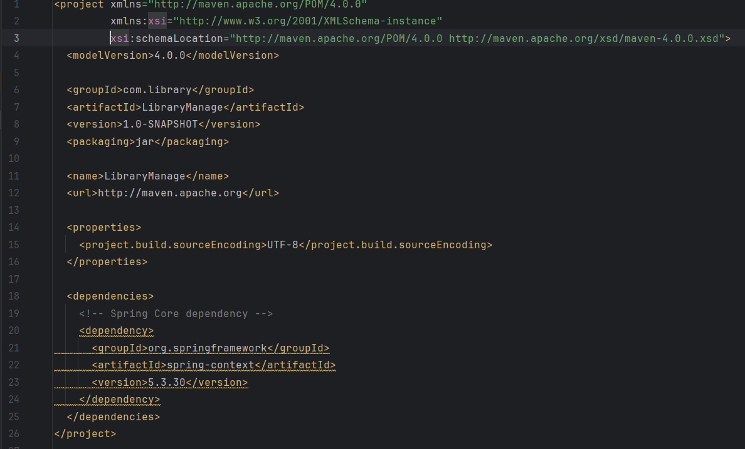

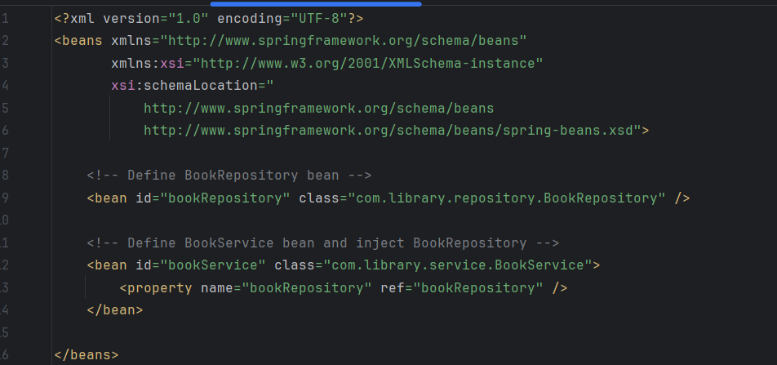Step2) Configure the Application Context:

Step3) Define Service and Repository Classes:

1. 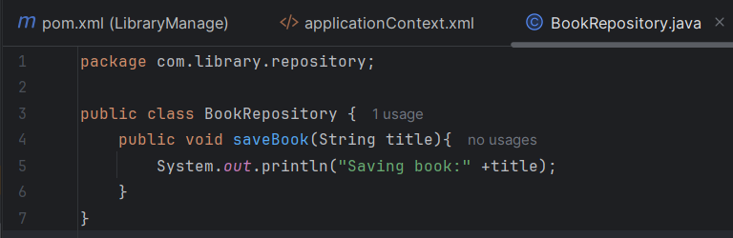Create BookRepository:
2. 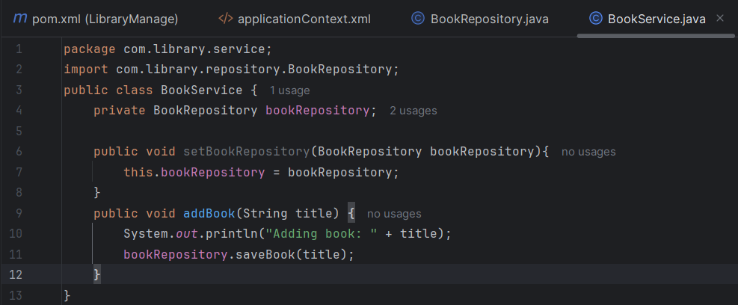Create BookService:

Step4) Run the Application

1. 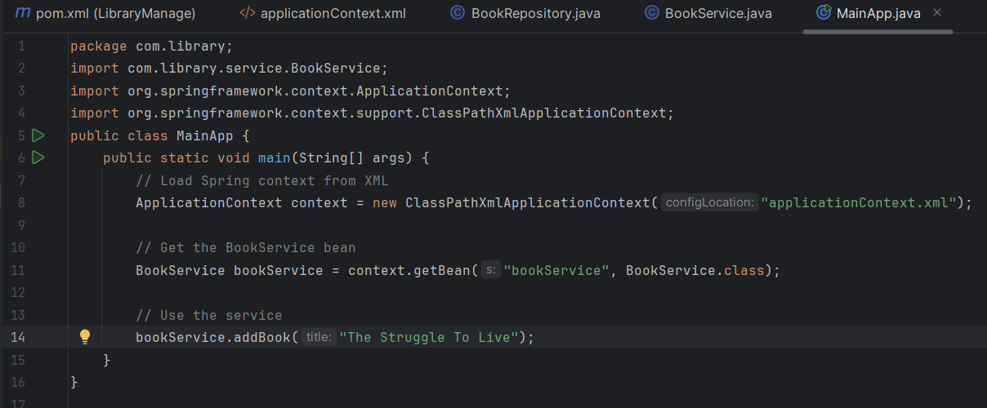Create a Main Class:

Output:

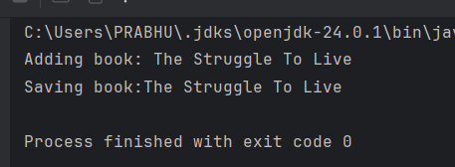

**Exercise 2: Implementing Dependency Injection**

**Scenario:**

In the library management application, you need to manage the dependencies between the BookService and BookRepository classes using Spring's IoC and DI.

**Steps:**

1. **Modify the XML Configuration:**
   * Update **applicationContext.xml** to wire **BookRepository** into **BookService**.
2. **Update the BookService Class:**
   * Ensure that **BookService** class has a setter method for **BookRepository**.
3. **Test the Configuration:**
   * Run the **LibraryManagementApplication** main class to verify the dependency injection.

Ans)

Step1) **Modify the XML Configuration:**

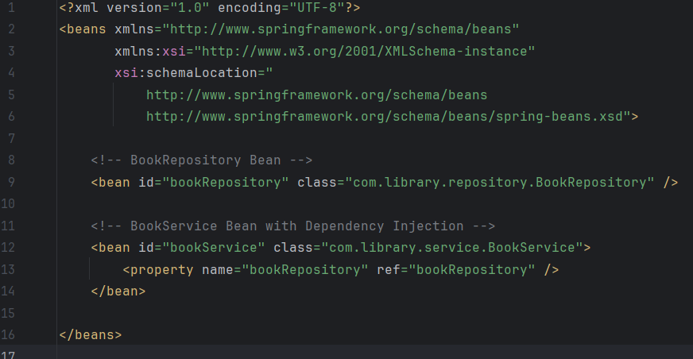

Step2) Update the BookService Class:

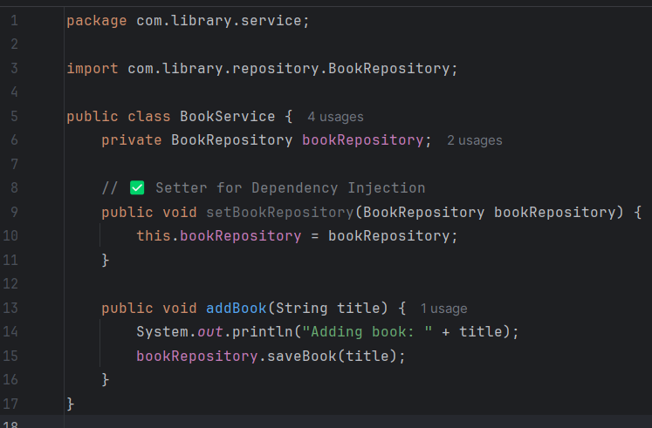

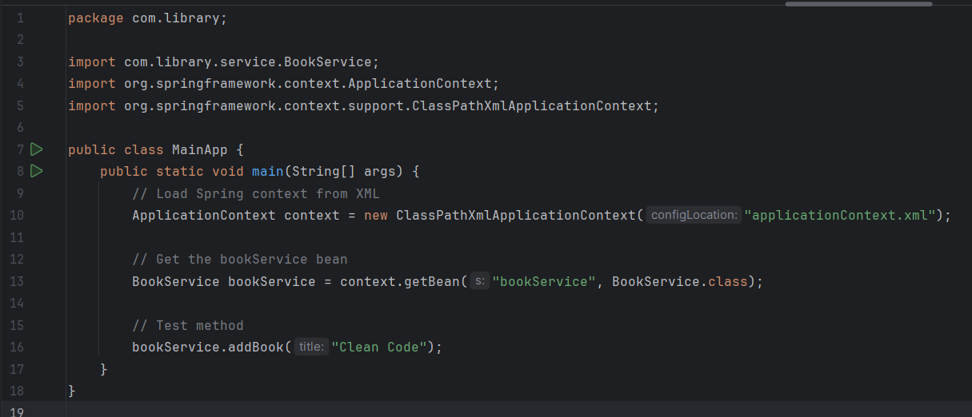Step3) Test the Configuration:

OUTPUT

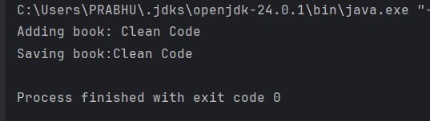

**Exercise 4: Creating and Configuring a Maven Project**

**Scenario:**

You need to set up a new Maven project for the library management application and add Spring dependencies.

Ans)

Adding of Spring Dependencies and Maven Plugins:

